

**What is the Work Experience Program?**

The Work Experience program works with a youth and a worksite to benefit both.  Youth who are having trouble finding jobs often find it easier to get employed if they have a current and a positive work record. It is easier to go from one job to another job, than it is to go from no job to a job. The Work Experience program helps match local youth with a business that needs extra help. The youth is paid through our office and covered by our worker’s compensation, so there is essentially no liability to the company.

Youth like it because it gives them:

* a chance to work and earn money ($12.50 per hour or more if the employer pays above minimum wage for entry-level employees)
* a current job to put on applications for other employers
* an opportunity to learn new work skills an possibly be hired at their Work Experience worksite (this is not guaranteed)
* a chance to prove that they are reliable, hard workers who can get the job done
* new references to use on applications for future employment

Businesses like Work Experience because it gives them:

* extra help that is paid for by our office
* a chance to try out a new employee to see if they are going to be reliable, on time, a quick learner and a good part of the team
* no obligation to hire the youth on, but you are free to do so at your choice
* a job developer to work with the business and the youth to help work through any difficulties
* a way to help build the local workforce for the future

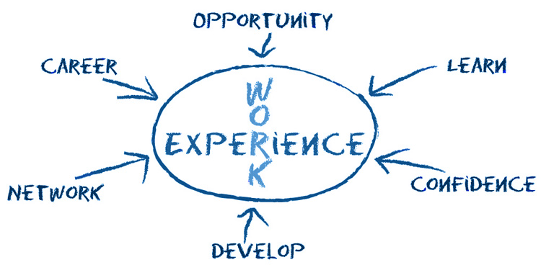**CONTACT *Susan Day 585-268-9445 or Liz Lingenfelter 585-268-9241 for more information***